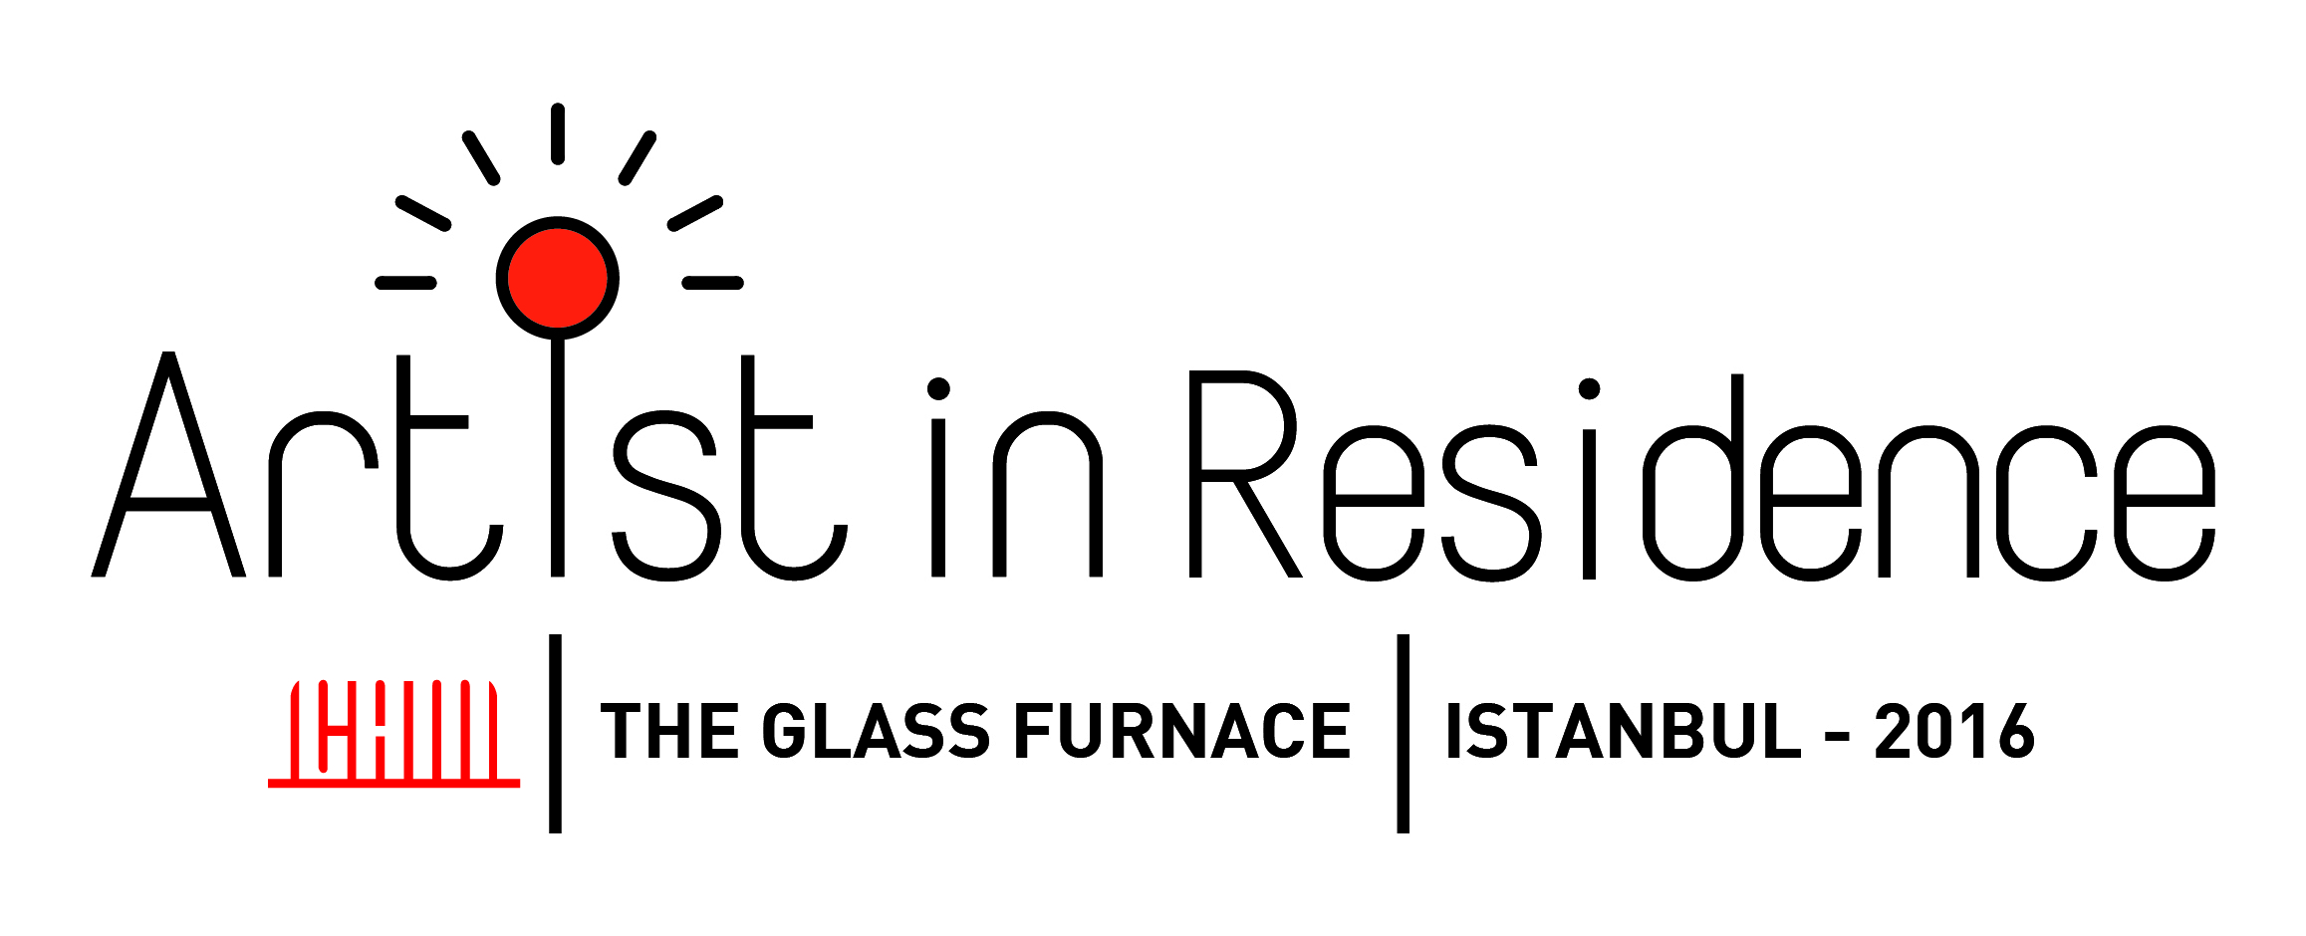

**APPLICATION FORM**

Name Surname:

Adress:

E-mail:

Phone Number:

Occupation:

Work/School Adress:

Emergency Contact and Number

Facilities you plan to use at The Glass Furnace

Hot shop Kiln Fusing

Do you need an assistant? Can you find the assistant?

Do you have any health issues we need to know?

Education and Employment Backgorund (Month/ Year ve Instutition)

Motive of Application and Production Plan

(Maximum 1000 words)

Prefered term:

February 1 – February 26, 2016

February 29 – March 25, 2016

April 4 – April 29, 2016

May 2 - May 27, 2016

I hereby agree to the terms and conditions set forth in the program outline and apply for the program.

Name Signature Date